Make “rip-able” to differentiate between vocabulary words after all 3 words have been developed
Weathering, erosion, deposition
- Rip a piece of paper to represent a rock, put tears in the rock to represent weathering, write a definition of weathering near rock
- Tear small pieces of paper to represent eroding sediment; write a definition of erosion by the eroding sediment
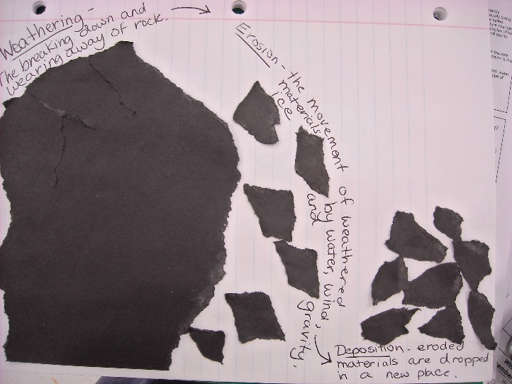
Glue a pile of eroded sediment at the base of the rock; write a definition for deposition near the pile

