Organization in Living Things
1
It can be said organization leads to efficiency. And in you, cells are organized into tissues, which are organized into organs, which are organized into organ systems, which form you. And it can be said that the human body is a very organized and efficient system.
Multicellular Organisms
2
Multicellular organisms are living things that are made up of more than one type of cell and have specialized cells that are grouped together to carry out specialized functions. Most life that you can see without a microscope is multicellular. The cells of a multicellular organism would not survive as independent cells. The body of a multicellular organism, such as a tree, cat, or person exhibits organization at several levels: tissues, organs, and organ systems. Similar cells are grouped into tissues, groups of tissues make up organs, and organs with a similar function are grouped into an organ system.
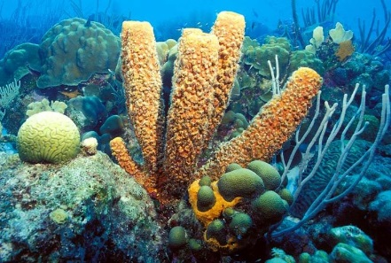
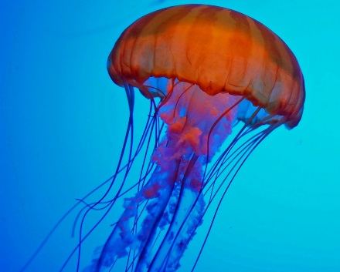
The simplest living multicellular organisms, sponges, are made of many specialized types of cells that work together for a common goal. Such cell types include digestive cells, tubular pore cells, and epidermal cells. Though the different cell types create a large, organized, multicellular structure — the visible sponge — they are not organized into true interconnected tissues. If a sponge is broken up by passing it through a sieve, the sponge will reform on the other side. However, if the sponge’s cells are separated from each other, the individual cell types cannot survive alone.
3
Tissue
4
A tissue is a group of connected cells that have a similar function within an organism. More complex organisms such as jellyfish, coral, and sea anemones have a tissue level of organization. For example, jellyfish have tissues that have separate protective, digestive, and sensory functions.
Organ
5
Even more complex organisms, such as the roundworm, while also having differentiated cells and tissues, have an organ level of development. An organ is a group of tissues that has a specific function or group of functions. Organs can be as primitive as the brain of a flatworm (a group of nerve cells), as large as the stem of a sequoia (up to 90 meters, or 300 feet, in height), or as complex as a human liver.
Organ System
6
The most complex organisms (such as mammals, trees, and flowers) have organ systems. An organ system is a group of organs that act together to carry out complex related functions, with each organ focusing on a part of the task. An example is the human digestive system, in which the mouth ingests food, the stomach crushes and liquifies it, the pancreas and gall bladder make and release digestive enzymes, and the intestines absorb nutrients into the blood.

