The sun supplies energy for evaporation and transpiration of water, causing frequent rainfall and humid temperatures in a rainforest is an example of Water Cycle. | Water Cycle
The warm ocean currents in the Gulf of Mexico and the Atlantic Ocean are warmer than the Pacific Ocean near California. Florida has more thunderstorms from colliding sea breezes than any other area of the United States. | Sea breezes
Morning fog occurs when the water vapor in the air is cooled and condenses just like condensation forms on the outside of a glass of iced tea. | Condensation
Earth’s surface would receive too much radiation and life would not exist without the Earth’s Atmosphere. | Atmosphere
Heat transfer from the sun radiant energy warms the Earth’s surface in uneven ways causing the circulation of air and winds across the globe. | Circulation
As a river flows from a high elevation to a lower elevation, you would expect more deposition of eroded particles to be at the wide, shallow, base of the lowest end of the river.  Show Image of an alluvial fan or delta | Deposition
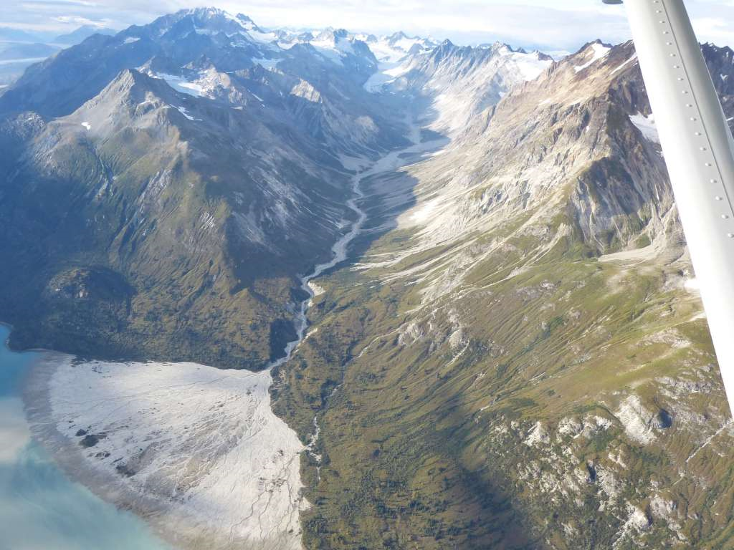 | Deposition image showing alluvial fan.
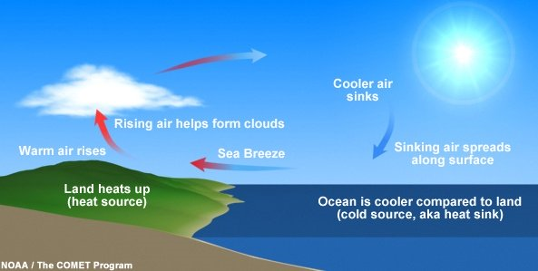 | During the daytime, solar radiation heats the sand making the air above it rise. This causes the cooler air above the ocean to rush into shore and you will feel a  Sea breeze.
The warm waters and moist air between Africa and Florida, during the months from June to Novemeber provide the perfect conditions to fuel the development of a hurricane. | Hurricane
Central Florida residents need to watch for unusual cracks in walls, floors, and roads; doors that won’t close; and circular depressions in the ground, as they might be warning signs of a sinkhole. | Sinkhole
The source of energy for our annual climate, daily weather, and the water cycle is the sun. | The sun
A fast moving river can deposit many particles that will eventually form sedimentary rock. This shows an interaction between the hydrosphere and the geosphere. | Geosphere
The atmosphere interacts with the geosphere when rocks are broken down through the process of physical or chemical weathering. | Weathering
Captains like Christopher Columbus avoided sailing their ships south to the warm waters and moist air around the equator because of the dangerous likelyhood that a hurricane would destroy their vessels. | Equator
Weather is the conditions occuring at a particulare place and at a certain time, while the long term average conditions collected over a long time (years) describe the climate of a region. | Climate
If you wanted to illustrate condensation in a drwing of the water cycle in the atmosphere, you might consider drawing a cloud formation in the sky. | Cloud
The land formation that is common in Polk County, that is circular in shape and filled with water is known as a sinkhole lake. | Sinkhole lake
An apple falling from a tree is an example of the force of gravity acting on an object from a distance. | Gravity
Multicelled organisms, like plants, get their cells from existing cells as they grow and develop. Supports the part of the cell theory that states: Cells come from preexisting cells. | Cell theory
Cells are the basic unit of life is the part of the cell theory that includes an organism made of one single cell like a protozoa. | Organism
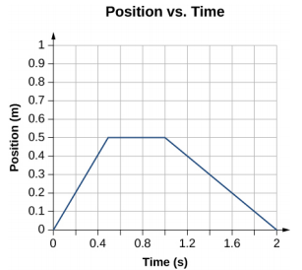  This Photo by Unknown Author is licensed under CC BY-SA-NC | Distance /Time Graph
To determine the fastest speed of an object, look at the slope of the line to see where the object travels the most distance in the shortest unit of time.  See graph | Slope
All living organisms must have cells that allow water and food into the cell and allow wasteto go out of their cells to maintain homeostasis within the cell / organism. | Homeostasis
Cells are the basic unit of life is the part of the cell theory that includes an organism made of one single cell like a protozoa. | Organism
Newton’s law of accelleration says that if a soccer ball is rolling toward a player who kicks it with all their force, the ball will change directions and increase its speed toward the goal. | Force
One common characteristic that all living organisms share is that they all must contain at least one cell. | Cell
It takes an unbalanced force to make an object move. And it takes an unbalanced force to stop a moving object. | Unbalanced
Electrical force and gravitaional force both act on objects at a distance; the difference is that electrical forces depend on the type of charge (+-) and gravitaional forces depend on the mass of the objects and how far apart they are. | Mass
An object has the most potential energy at its highest point in the air. | Potential
You want to investigate how forces act on a toy car’s speed. You make 3 ramps using boards and bricks. You cover each board so that the texture of the surface of each is different. Then your team measures the distance and times of each car in a data table. The contact force you are testing is friction. | Friction
As scientists find new evidence that contradicts a theory, the theory will change. | Theory
Riding up a hill, energy will be transformed from kinetic energy into potential energy, and going down a hill the energy will be transformed from potential to kinetic. | Kinetic
If a beach ball, a volley ball, a steel marble, and a bowling ball are each placed 2 meters from a tiger’s eye glass marble. The bowling ball will exert the greatest gravitational force on the glass marble because it has the greatest mass. | Gravitational
All of the objects in the solar system each exerts a gravitational pull. It is the distance apart and the object’s mass that determines the effects of the pull. | Distance
Scientific Knowledge improves over time because as new information is collected, recorded, and interpreted, the scientific knowledge will change. | Scientific Knowledge

